Budget Consultation Results
The consultation concentrated on a number of key areas which are shown with 13 responses being received. The results for each are detailed below:

Council Priorities

Consultees were asked to rank the Councils priorities in order of importance

New and Continued Investment
The City Council's Corporate Plan and Budget 2015 -19 set out its support for a number of investment proposals made in previous years, along with some new ones. For each investment proposal consultees were asked to indicate to what extent they agreed or disagreed with the areas.

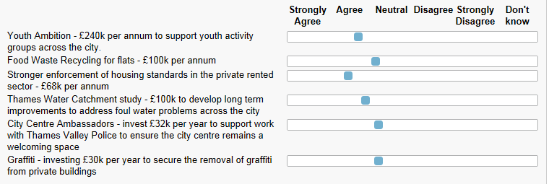

Council Tax Increase
Consultees were asked to give their opinion on the proposed level of council tax increase for 2015/16 of 1.50% together with an increase up to the referendum level of 1.99% and also a council tax freeze. The results were as follows:

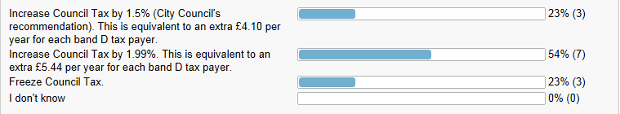

Council Tax Support
The Consultation budget assumes the Council retains the Council Tax Support scheme on the same basis as that introduced on 1st April 2013. The Council are recommended to agree to maintain the scheme at this level for 2015/16.

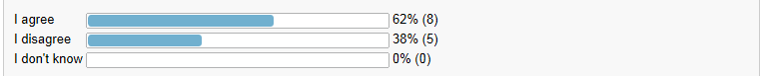
Fees and Charges
While the Council proposes that most charges such as those for garden waste, building control and planning and will remain at 2014 -15 prices, its draft Medium Term Financial Strategy does propose to increase some fees and charges over the next four years. Consultees were asked to indicate whether they agreed or disagreed with the following specific proposals:

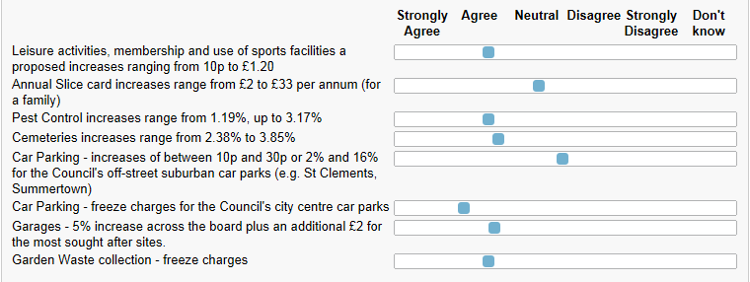

Housing Revenue Account

The following is a list of the main proposals in Oxford City Council’s Housing Revenue Account. Consultees are asked to indicate whether you agree or disagree with these proposals.

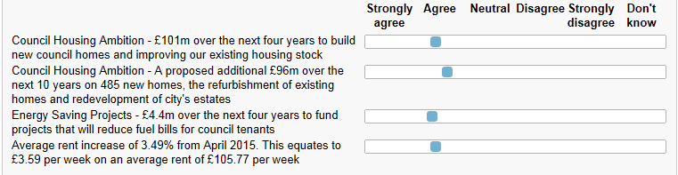
Capital Investment
Consultees were asked to give their views on the capital investment being undertaken by the Council over the next four years. 